**SCIENTIFIC COMMITTEE**

**TWENTY FIRST REGULAR SESSION**

Nuku’alofa, Tonga

13-21 August 2025

**Ecosystem and climate indicators of the western and central Pacific Ocean**

**WCPFC-SC21-2025/EB-WP-01**

**25 June 2025**

Nicholas J Hill1, Simon Nicol1, Joanne Potts1, Bernadette Sloyan2, Thomas Moore2

Contents

Executive Summary 3

Introduction 4

2024 environment summary 6

Proposed indicators 7

Indicator 1: Centre of gravity (COG) of the purse seine fishery 7

Indicator 2: Size composition of tunas 12

Annex 1: Terms of reference for adopting ecosystem and climate indicators 16

Annex 2: Suva ecosystem and climate indicators workshop summary 17

Workshop agenda 17

Workshop participants 19

Annex 3: Exploring evidence of climate change driven shifts in the longitude of WCPFC purse seine effort 20

Introduction 20

Method 21

Results 24

Discussion 27

References 30

# Executive Summary

This Working Paper updates SC21 on progress regarding development of a climate and ecosystem indicators report for the western and central Pacific Ocean (WCPO).

The ecosystem and climate indicator recommendations of SC20 were:

* note the progress towards implementing the SC19 endorsed Ecosystem and Climate Indicators Workplan.
* note the delay in the first expert workshop due to travel disruptions associated with the civil disturbances through May-July in New Caledonia.

This working paper notes that a workshop was successfully held in Suva, Fiji 25-26th November 2024 that brought collaborators together from a range of organisations to inform development of a workplan and indicators.

A series of ecosystem and climate indicators have been proposed and presented since SC17. This paper presents further refinement of these candidate indicators and suggestion of several new ones with the commencement of collaboration from CSIRO. This also included exploration of how the longitudinal distribution of the WCPFC purse seine fleet has changed over time using modelling approaches to inform and improve development of fisheries indicators in Annex 3. It also details a continued workplan…

### Recommendations

We invite WCPFC21 to note the results of this updated climate and ecosystem indicators report and present recommendations for future work:

* Note the successful undertaking of a workshop in Suva, Fiji in November 2024 that brought collaborators together from a range of organisations to inform development of a workplan and candidate indicators.
* Note the continued development and refinement of climate and ecosystem indicators for routine updating and presenting to future SC meetings.
* Note the results of analysis that explored the development of a modelled indicator that investigated long-term shifts the longitudinal distribution of WCPFC purse seine effort while accounting for variables known to influence fishing location.
* Note the need for continued support of research focused on developing methods that can identify and monitor climate change-related impacts on the WCPO and its associated fisheries.
* Note the updated workplan for ecosystem and climate indicators research for 2025-26.

# Introduction

The Western and Central Pacific Ocean (WCPO) contains major oceanic currents and circulation pathways. These pathways redistribute waters from different parts of the Pacific Ocean such as the North and South Pacific subtropical gyres to the equator and extra-tropical regions. The circulation of the WCPO is complex, with large currents that vary substantially and include asymmetries and gating effects across various timescales.

These complex currents carry water masses with distinct ocean properties (e.g. temperature, salinity, oxygen and nutrients). Changes in the intensity and position of these currents therefore influence broader trends in temperature, salinity, oxygen, and nutrient distribution of the WCPO. Adding to this ocean current and property variability, the El Niño-Southern Oscillation (ENSO) is the strongest interannual climate signal globally, profoundly influencing tropical and equatorial Pacific Ocean circulation and property distribution.

This variability in equatorial currents and associated climate phenomena have flow-on effects and consequences for marine ecosystems. Ocean circulation, including key processes like mixing, upwelling, and advection, along with the resulting temperature, salinity, and oxygen distributions, fundamentally shape marine ecosystems. Tunas and other highly mobile pelagic species are well known for moving with favourable environmental conditions related to temperature, productivity, and upwelling. As a result, fisheries adapt to these conditions, following shifts in the distribution of preferential environmental conditions and tuna dynamics to maximise catches. For example, there is a well-known eastward shift in purse seine effort and catch during el nino events due to an eastward expansion of the western pacific warm pool as a result of weakening trade winds and surface currents from the eastern pacific (Lehodey et al., 2020, 2003).

The environment and climate are continuously influencing tuna fisheries in the Pacific Ocean. Climate change is and will influence and exacerbate these effects. For example, climate change predictions suggest an eastward expansion of the western pacific warm pool and with it, an eastward shift in tuna biomass (Bell et al., 2021; Weller et al., 2016). If tuna biomass does shift, this will have flow on effects to Pacific Island countries and territories (PICTs) which are highly dependent on fisheries for food security and as a source of income (Bell et al., 2015; Gillett and Fong, 2023). In response to the effects of climate change, fisheries administrations are increasingly looking at ways to monitor and adapt to its effects (Taylor and Walter, 2024).

Within tuna regional fisheries management organisations (RFMOs), climate and ecosystem indicator reports are now being regularly produced to monitor environmental conditions and to track if any underlying shifts in ecosystems, fisheries or species of interest are occurring (Griffiths and Fuller, 2019; Juan-Jordá et al., 2018; SPC, 2023). Since 2015, the WCPFC Scientific Committee (SC) has explored the development of ecosystem and climate indicators to help inform the management of fisheries targeting tuna and tuna-like species in the WCPO (Anon, 2015; Smith et al., 2016). A series of reports have subsequently been produced since SC11 in 2015 describing the objectives and testing criteria for these indicators, and a set of candidate indicators have been produced since 2019 at SC15 (Allain et al., 2021, 2020; Juan-Jordá et al., 2019; SPC, 2024, 2023, 2022). Text from previous SC papers that outlines the terms of reference and process for adopting these indicators is provided in Annex 1 (Smith et al., 2016; SPC, 2022).

This report represents a continuation of this work in presenting a set of updated ecosystem and climate indicators for adoption by the SC. These indicators will help inform SC and the WCPFC Commission on the current state of the ecosystem and climate of the WCPO and any prevailing trends that are likely to influence the sustainability and management of tunas, their fisheries and surrounding ecosystems. The purpose of this report is that it will be adopted by the Commission and routinely produced to provide up-to-date information to the SC and WCPFC Commission to help inform decision-making and support its application of an ecosystem-based approach to fisheries management (EAFM).

As part of this ongoing work of developing ecosystem and climate indicators, a workshop was recently held in Suva, Fiji November 2024 to develop a workplan and discuss candidate indicators. Details of this workshop have been provided in Annex 2. In summary, this workshop brought together approximately 25 participants both in person and online from a range of organisations including SPC, NOAA, WCPFC, private sector, NGOs and member country representatives. The intent of the workshop was to discuss the development of a series of indicators that accurately detail the current marine climate for the Pacific region and its fisheries so that it can better monitor and adapt to the effects of climate change.

### Objectives

The intent of this report is to present an up-to-date state of the ecosystem and climate report for the WCPO to help inform the management of tuna and tuna-like species by the WCPFC. The indicators intend to provide an outlook of the current state of the environment, natural variability and any underlying persistent changes across key oceanographic features and associated tuna fisheries that may affect their sustainability and management. Here, six indicators are presented that summarise the ecosystem and climate of the WCPO such as sea surface temperature variability and area of the western pacific warm pool as well as several fisheries indicators.

For selection, indicators had to meet the criteria detailed in Annex 1 which required a combination of the indicator being reflective of the current environment, responsive to changes, cost effective, and science-based among others. Based on these criteria, the following indicators selected were:

1. Sea surface Temperature variability
2. Depth of the 20oC subsurface ocean isotherm and variability from the mean state
3. Area and volume of the western pacific warm pool and variability from the mean state
4. Depth and thickness of Oxygen depleted waters where oxygen depleted waters are defined as 1.5 - 3 mL/Litre (45-90 umol kg-1)
5. Chlorophyll/productivity?
6. Centre of gravity (COG) of the purse seine fishery
7. Area of longline and PS fishery?
8. Size composition of tunas

Below, a rationale for the inclusion of each indicator is given along with a summary of their status and trends over time.

# 2024 environment summary

The year 2024 was the hottest on record for much of the WCPO (WMO, 2025). Sea surface temperatures (SST) have risen in line with the global mean of approximately 0.13oC per decade (WMO, 2025) . Some areas of the Pacific Ocean are warming faster than this average, with the Coral, Tasman, and Solmon Sea’s warming quicker than the global average (CSIRO and BOM, 2025). A recent report on the effects of climate change on Pacific Island Countries and Territories (PICTs) found sea surface temperatures across pacific islands are increasing (McGree et al., 2022). Marine heatwaves and coral bleaching events have become increasingly common and severe, with 2024 marking a record high in marine heatwave coverage with events recorded across PICTs and Australia (CSIRO and BOM, 2025; WMO, 2025).

The El Nino Southern Oscillation (ENSO) phase is currently neutral with a Southern Oscillation Index (SOI) value of -0.06oC in June 2025 where ±0.8oC marks an El Nino or La Nina event (http://www.bom.gov.au/climate/enso/). This neutral event is expected to continue until at least December. This follows a weak El Nino event that occurred between June 2023 and March 2024 which marked anomalously high sea surface temperatures and coral bleaching events throughout the WCPO.

The Interdecadal Pacific Oscillation (IPO) is a long-term natural climate oscillation that occurs at decadal, or multi-decadal timescales (https://psl.noaa.gov/data/timeseries/IPOTPI/). The IPO is measured using the tripole index which determines the difference between the average SST anomaly over the central equatorial Pacific and northwest and southwest Pacific Ocean. It is currently in a negative phase which is marked by cooler than average temperatures in the equatorial Pacific, and warming in the western and southern Pacific Ocean. This negative phase has been ongoing since 1999 and was thought to be potentially buffering some of the warming impacts of climate change. Considering that this negative phase has been ongoing for 26 years, the probability of a shift to a positive phase is increasingly likely.

Primary productivity is predicted to decrease with climate change as stratification of the water column increases and nutrients reaching the surface decreases. Phytoplankton is used to estimate productivity which is monitored using satellite remote sensing to measure chlorophyll-a concentration in surface waters. However, there is currently no evidence that primary production has decreased in the tropical Pacific region over the last decade, contrary to predictions (SPC, 2023)). Since 1989, an oceanographic monitoring station has conversely shown an increase in primary productivity that may be linked to multi-decadal IPO phase (https://hahana.soest.hawaii.edu/hot/hot-dogs/ppseries.html).

# Proposed indicators

## Indicator 1: Centre of gravity (COG) of the purse seine fishery

Rationale: The WCPFC purse seine fishery predominately operates in the western pacific warm pool. The warm pool is a large, warm body of water at or above 28oC that sits in the equatorial western pacific. The warm pool naturally varies in size and extent with changes in the environment, and in particular with ENSO events, which influences where effort and catch consequently occurs in the purse seine fishery (Senina et al., 2008). The warm pool is also considered as an important spawning ground for tuna species, in particular skipjack tuna and so changes in its size, structure or position may also influence the productivity of tuna (Ashida, 2020; Fujioka et al., 2024).

With the impacts of climate change, the warm pool is predicted to increase in size, driving a potential eastward shift in tuna biomass (Bell et al., 2021; Lehodey et al., 2013). By monitoring the centre of gravity (COG) of purse seine effort and catch, we can monitor if fisheries are responding to these predicted changes and by proxy tuna dynamics. Any shift in the location of the purse seine fishery is also relevant as it relates to income for PICTs when fishing occurs in their EEZ.

Status: For effort, there is a clear distinction in trends over time by set type (Figure 1). For unassociated sets, effort COG shows interannual variability but no clear underlying trend from 1990-2023. In contrast, there is an eastward shift in the COG of drifting FAD-associated sets over time. It is difficult to determine if this is a climate related shift in the warm pool and tuna dynamics, or if it is a shift in fishing behaviour driven by increased uptake of FAD-associated fishing. Equally, the lack of movement in the unassociated set component of the fishery could suggest tuna haven’t shifted, or that the fishery has not yet adapted to change and may be driven by other factors such as distance to port.

For catch, there is an underlying eastward shift in all three tuna species, however the strength of these trends is variable (Figure 2). Bigeye tuna (BET, *Thunnus obesus*) shows the most prominent eastward shift over time, followed by skipjack tuna (SKJ, *Katsuwonus pelamis*) and yellowfin tuna (YFT, *Thunnus albacares*) which show a very small eastward shift. Interannual variability is also present in the COG of catch of all three species as is present in effort. As with effort, it is difficult to disentangle shifts in tuna and changes in fishing behaviour to explain these underlying trends.

To disentangle the effects of these variables (e.g. set type, ENSO) on purse seine COG over time, the longitudinal distribution of purse seine effort was modelled accounting for a number of these variables (see Annex 3). The results of this analysis are summarised in Figure 3 comparing outputs from the analysis with COG indices of catch and effort. Outputs from the model showed a variable trend in longitude over time, with an eastward trend in the WCPFC purse seine fishery from 2008 onwards. It was also apparent from the analysis that different flagged vessels are behaving differently within the fishery, with some flexibly fishing throughout the convention area while others consistently fish similar regions each year. This suggests that if climate change does affect the distribution of tuna, that some vessels and flags will be more susceptible to these changes than others.

Description: Best estimates of total purse seine catches of BET, YFT and SKJ were used to determine the COG of catch, and best estimates of effort by set type for the COG of effort. Data used were extracted from SBEST databases using raised (aggregated) 1x1 degree purse seine fishery data where set type information was available. Catches and effort were constrained to WCPFC regions 6-8 (latitude: -20oS – 10oN, longitude: 140oE – 210oE) and from years 1990-2023 (Vidal et al., 2020). Catches and effort from domestic Indonesian, Vietnamese, and Philippines flagged vessels were not considered given differences in vessel class and fishing strategy. Associated purse seine sets were considered as sets made on drifting FADs only, floating objects and anchored FADs were not considered in this analysis. The COG is an annual estimate of the weighted mean position of catch and effort where the number of sets is used to weight the effort COG, and catch to weight the catch COGs by species.

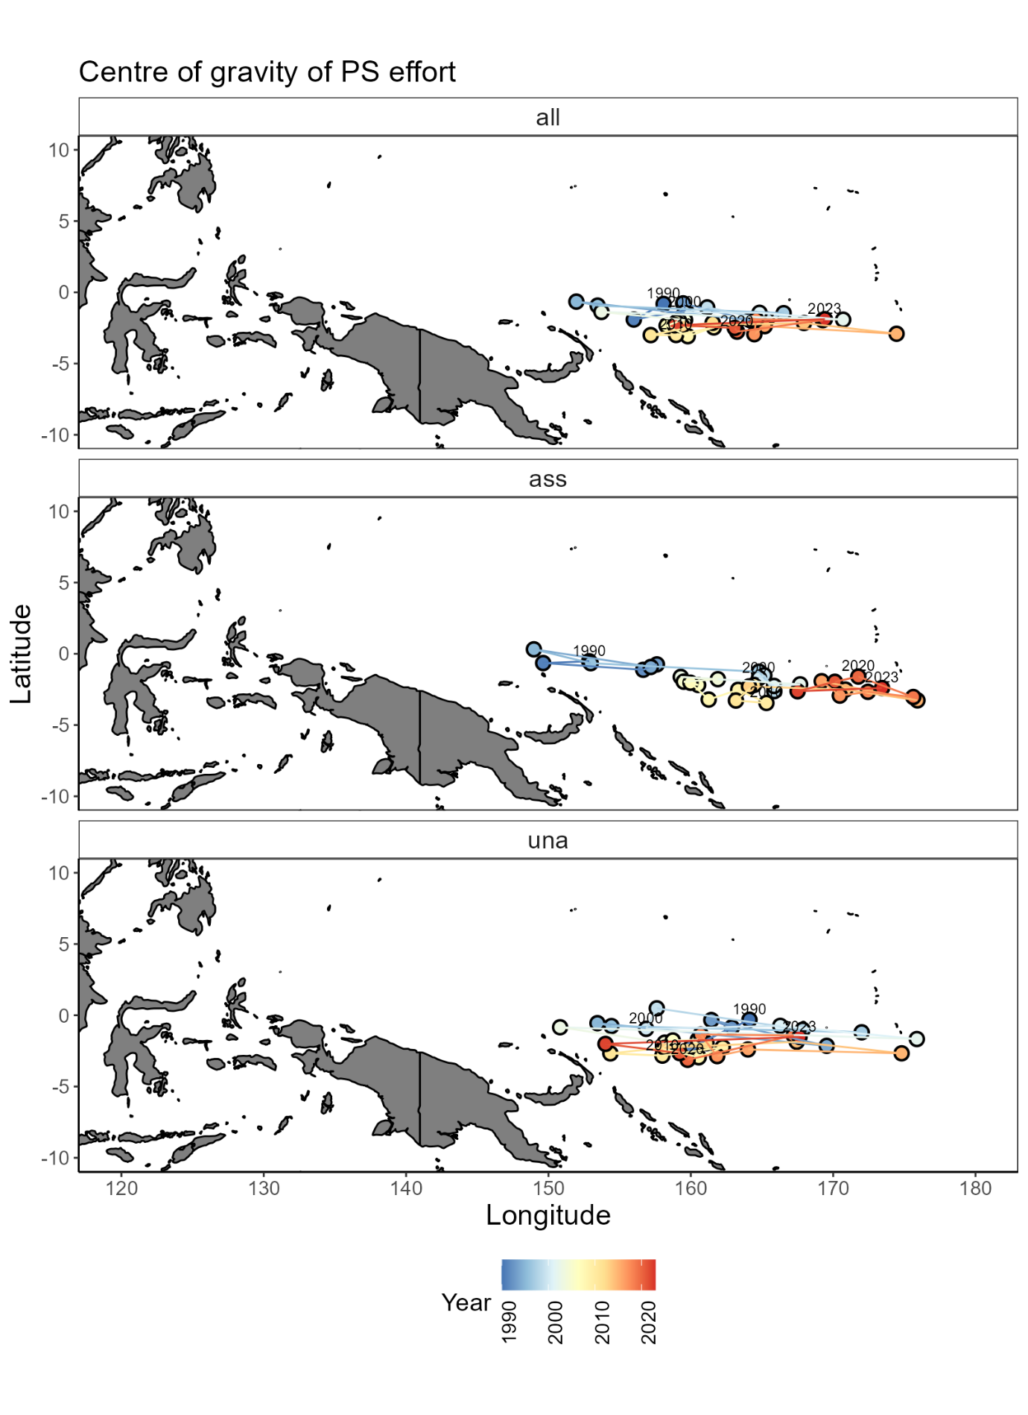

Figure 1: Centre of gravity of WCPFC purse seine effort by set type: all sets (all), drifting FAD-associated sets (ass), and free-school unassociated sets (una) from 1990-2023.

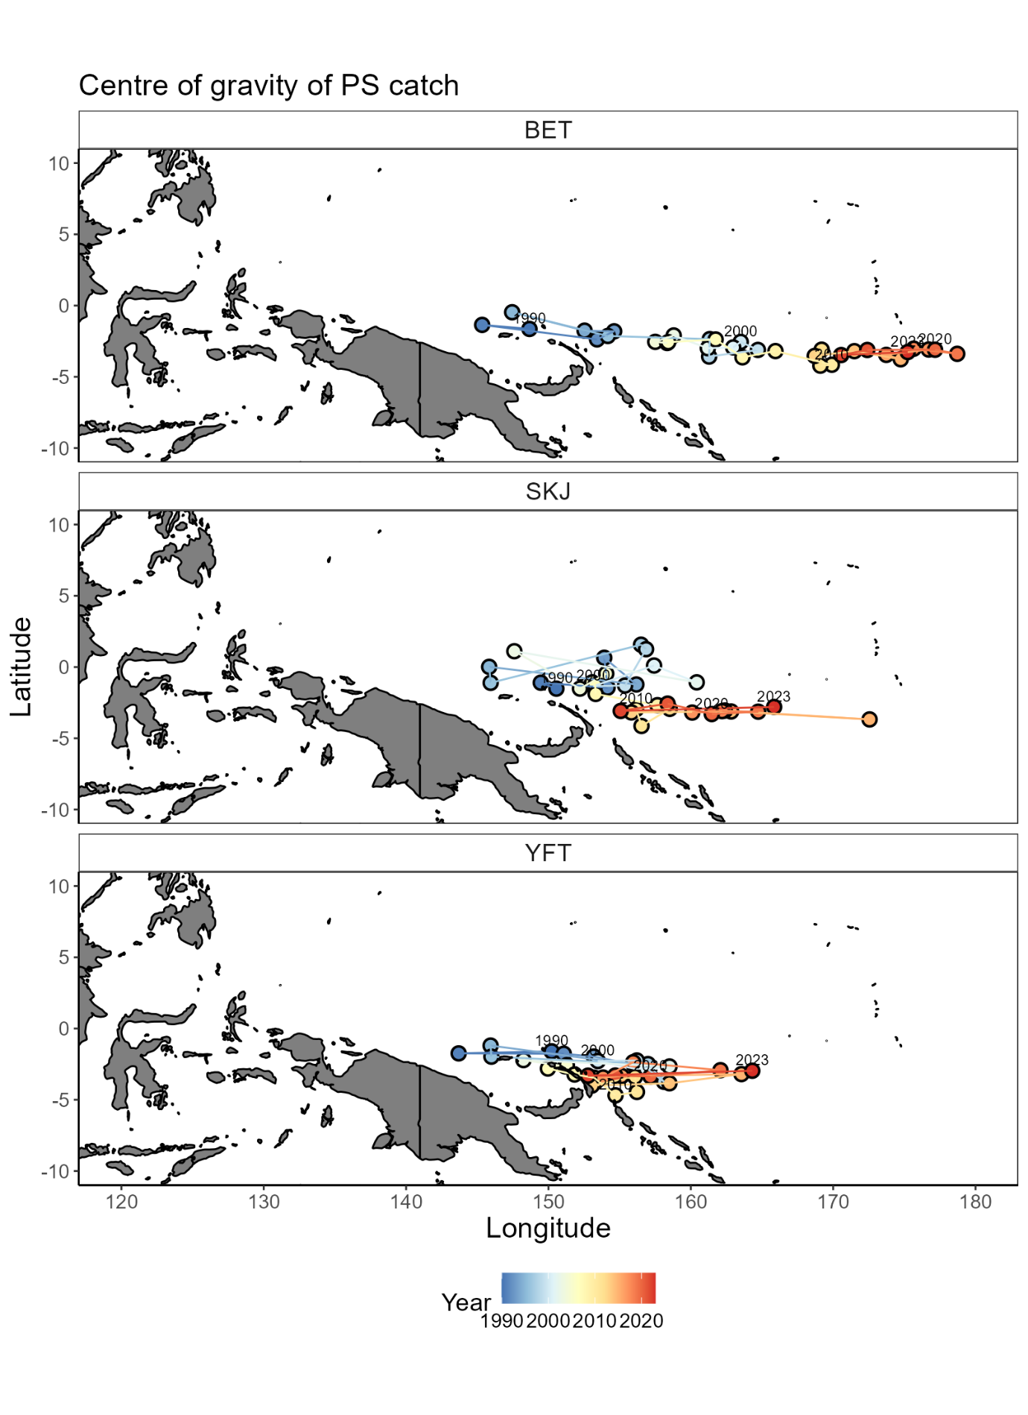

Figure 2: Centre of gravity of WCPFC purse seine catch of bigeye tuna (BET), skipjack tuna (SKJ), and yellowfin tuna (YFT) from all sets from 1990-2023.

Figure 3: Comparison of indices used to monitor the longitudinal distribution of the WCPFC purse seine fishery from 1990-2023. Black = modelled longitude. Red = unstandardised mean longitude of effort. Blue = COG of catch. Green = COG of effort. Dashed black = Mean longitude from 1995-2005.

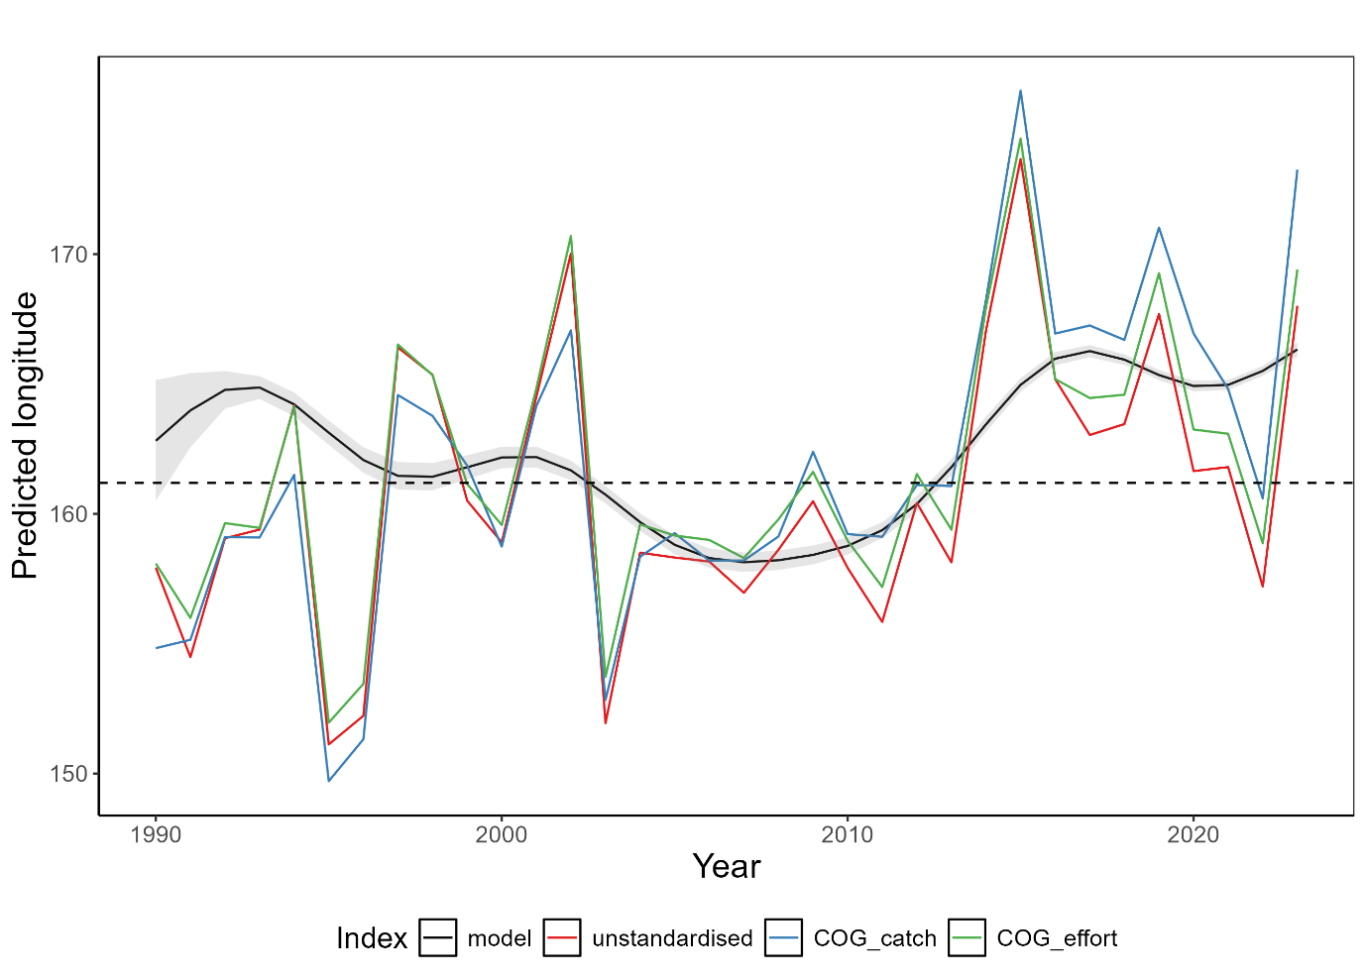

## Indicator 2: Size composition of tunas

Rationale:The size composition of a fish population is influenced by a range of factors including fishing and its environment. For example, changing oceanographic conditions could influence prey availability having knock-on effects to fish size composition. How the environment and climate change is influencing tuna size composition is not well known. However, by monitoring tuna size composition, any changes can be identified which can help determine sustainability of the fishery and inform management decisions.

Status:Trends in the size composition of tunas has varied from 1990-2023 (Figure 4; Figure 5). This is likely a reflection of several factors including changes in sampling design, fishing behaviour, and the underlying environment and populations.

For bigeye tuna (BET), their size composition has fluctuated over time rising to values above the 1990-2000 average of 122cm from 2007-2012 before declining to approximately 2018. In recent years, length composition has increased and the mean length in 2023 of 125cm is above the historical mean. Throughout this time, most BET catches in the longline fishery are above the length at 50% maturity of 103cm (Farley et al., 2017).

For SKJ, their size composition has been more variable which is likely a reflection of fishing and sampling programs. In recent years, SKJ size composition has declined with nearly 75% of the length composition below the historical mean length of 51.3cm in 2022. Unlike YFT and BET, catches have predominately been below the length at 50% maturity of 55cm which is in part due to most catch and sampling coming from the purse seine fishery (Ohashi et al., 2019).

For YFT, a decline in their size composition since 2012 is apparent. From 2000-2010, they show a similar trend to BET where their size composition declined in the early 2000s before rising around 2010. However, in contrast to BET their size composition has since declined and consistently remained below the historical mean value of 120.8cm since 2012, with a 2023 mean length of 113.9cm. Like BET, most of the size composition remains above the length at 50% maturity of 105cm (Magnusson et al., 2023).

For both BET and YFT, there is a slight upward trend in the proportion of small fish caught (<105cm), and a decrease in the proportion of large fish caught (>140cm) throughout the timeseries (Figure 5). However, this trend is not clear, and recent years have shown a shift in the opposing direction. This could be due to several reasons including increased fishing pressure driving the removal of large individuals from the population, an increase in small individuals in the population from enhanced recruitment, or a consequence of disrupted sampling programs due to COVID19 for example. There were no clear trends in the size composition of SKJ, with slightly positive trends in both the number of small (<45cm) and large fish (>63cm) being sampled over time.

Description:Length composition data for the three tuna species were derived from observer and port sampling programs from SPC databases for the years 1990-2023. Longline data was used for BET and YFT, and a combination of longline and purse seine data for SKJ. Where required, total (or other) lengths were converted to fork length measurements using well established conversion factors (Macdonald et al., 2023, 2022). Any outliers in the data were removed and length composition metrics extracted. This included estimating a three-year rolling mean of: 1) small fish: the percentage of fish that were below the 20th percentile of fish sampled from 1990-2000, 2) mean fish: the percentage of fish above the mean length of fish sampled from 1990-2000, and 3) big fish: the percentage of fish above the 80th percentile of fish sampled from 1990:2000. By monitoring these three indicators rather than just the mean length, an improved understanding of a species size composition is gained.

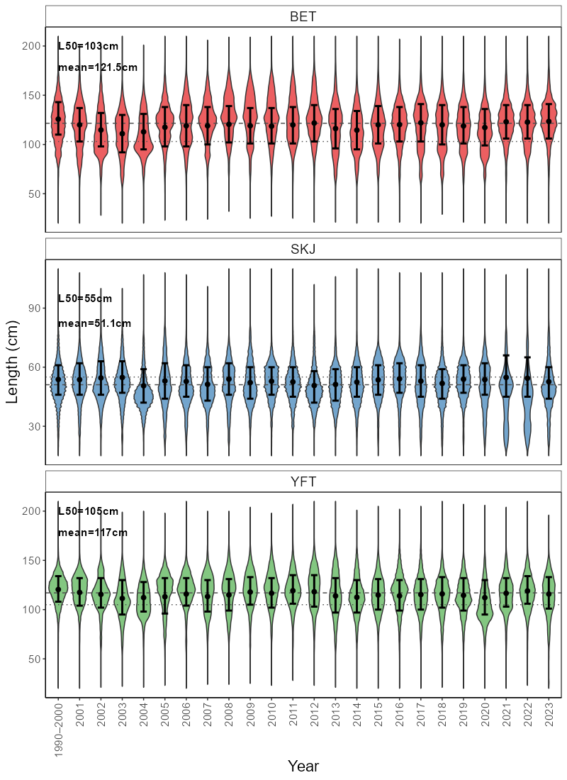

Figure 4: Length composition (cm) of bigeye tuna (BET), skipjack tuna (SKJ), and yellowfin tuna (YFT) in WCPFC longline fisheries (plus purse seine for SKJ) from 1990-2023. Dashed line = mean length from 1990-2000, dotted line = length at 50% maturity. Black dot = mean length with 25th-75th percentile error bars.

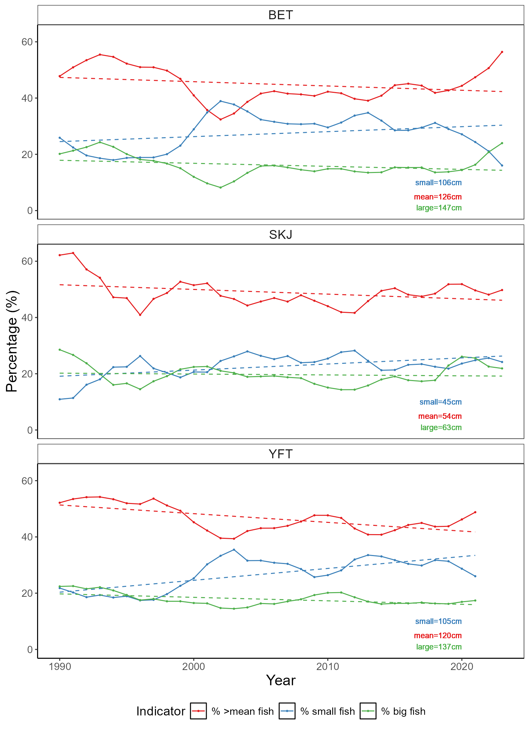

Figure 5: Length indicators for bigeye tuna (BET), skipjack tuna (SKJ), and yellowfin tuna (YFT) in WCPFC longline fisheries (plus purse seine for SKJ) from 1990-2023. Blue = % of fish below the 20th percentile measured from 1990-2000. Red = % of fish above the mean length measured from 1990-2000. Green = % of fish above the 80th percentile of fish measured from 1990-2000. Dashed lines represent linear models fit to each line to get a general trend line.

# Annex 1: Terms of reference for adopting ecosystem and climate indicators

The text below was extracted from (SPC, 2023).

### Terms of Reference

*A drafted terms of reference for the Ecosystem and Climate Indicators project was provided as Annex 3 to SC18-EB-WP-01 with the following specified objectives and scope of work:*

##### Objectives

* *Develop and test candidate ecosystem and climate indicators to track the impact of climate and ecosystem changes on WCPFC fisheries and ecosystems.*
* *Provide technical advice to the Scientific Committee on the suitability of criteria used for testing and evaluating the performance of candidate indicators.*
* *Support the Scientific Committee in developing tools to communicate ecosystem and climate change impacts to WCPFC and external stakeholders and interest groups.*

##### Scope of Work

* *Technical analyses to develop and test candidate indicators.*
* *WCPFC member and expert workshops to refine indicators.*
* *Scientific Committee reporting.*
* *Routine preparation of adopted indicators.*
* *Development of tools for communication to WCPFC and wider stakeholders.*

*The SSP was tasked by SC18 to develop a workplan for this project to be endorsed by SC19 and to develop an associated budget.*

### Process for adopting indicators

*SC12 noted that developing a thorough understanding of how to interpret potential indicators, their appropriate reference levels and baselines, and how reliable they are for prediction were critical steps for indicator adoption by the WCPFC Scientific Committee (SC). Criteria for developing and testing candidate indicators has subsequently been proposed to the Scientific Committee:*

* *science and data based;*
* *characterize the states and trends of WCPFC marine ecosystems with respect to fishing activity and/or climate (including reference levels and baselines);*
* *reflect well-defined processes underlying fishing activity and fishery responses to climate;*
* *responsive to changes attributable to fishing pressure and climate (i.e. having minimal time-lags and capability to provide early warning);*
* *estimable on a routine basis with a historical data time-series available;*
* *cost-effectiveness;*
* *scalable across national, sub-regional and regional scales;*
* *linked to existing WCPFC models and decision-making processes (for inclusion in MSE scenarios, validation of predictions and testing of model assumptions);*
* *can be routinely estimated by members without reliance on the Science Service Provider.*

# Annex 2: Suva ecosystem and climate indicators workshop summary

An ecosystem and climate indicators workshop was held in Suva, Fiji November 25-26th 2024 at SPC Nabua campus. This workshop brought together approximately 25 participants both in person and online from a range of organisations including SPC, NOAA, WCPFC, private sector, NGOs and member country representatives. The intent of this workshop was to discuss the development of a series of indicators that accurately detail the current marine climate for the Pacific region and its fisheries so that it can better monitor and adapt to the effects of climate change.

Over the two days, a range of presentations and discussions were held discussing:

* the terms of reference and framework decided upon by SC to guide indicator development;
* Potential climate-related indicators and major oceanographic features of the WCPO;
* Potential fisheries and ecosystem-related indicators;
* Exploration of how indicators can be designed and tested to best monitor the ecosystem and climate.

Outcomes from this workshop included the detailing of a workplan to develop an ecosystem and climate indicators report with the intent to deliver this report and its outcomes to WCPFC Commission meeting in November 2025.

## Workshop agenda

**WCPFC Climate Indicators**

**Draft Agenda**

Monday 25th November 2024, Fei Finomo Meeting Room Room, SPC Nabua (2nd Floor Lotus), Suva, Fiji, 9:30am-16:00pm

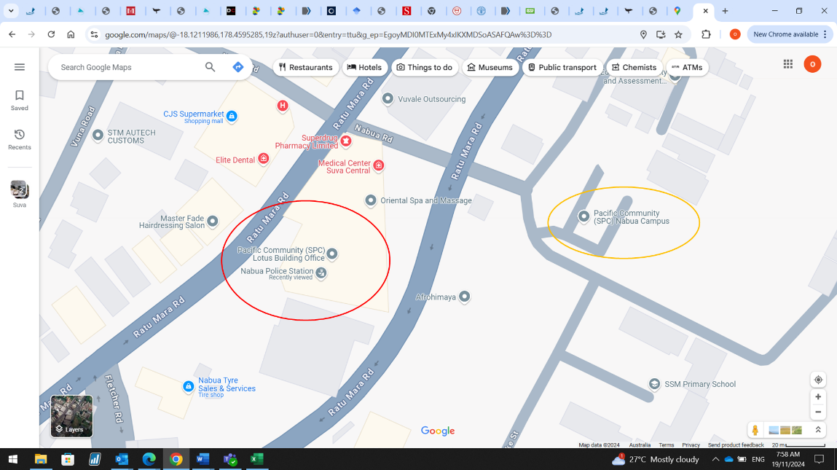

SPC has two campuses in Nabua. Our meeting is in the Lotus building (2nd Floor) (see red circle on screenshot). The Lotus building is above the Nabua police station. Entrance to the right of the police station entrance. If you get dropped off at the main campus (orange circle on screenshot) it’s a short 200m walk to the lotus building.

|  |
| --- |
| Agenda Item |
| 1. Introduction |
| 1. WCPFC Climate Indicators Overview    1. Indicator Framework    2. Candidate Regional Indicators |
| 1. Climate Indicators    1. Ocean State Reporting    2. National and Regional Ocean Indicators & Trends |
| 1. Fisheries Tuned Indicators    1. SDM    2. SEAPODYM    3. Fisheries    4. Decision related |
| 1. Framework for testing    1. Breakpoints    2. Track CC impacts    3. Empirical vrs Modelled |
| 1. Reporting    1. Met Services    2. Portals |

Tuesday 23rd November 2024, Fei Finomo Meeting Room Room, SPC Nabua (2nd Floor Lotus), Suva, Fiji, 9:30am-12:00pm

WCPFC Climate Indicators

|  |  |
| --- | --- |
|  | 1. Co-design/Resourcing    1. Collaboration network    2. Data Access |
|  | 1. Work plan |

## Workshop participants

|  |  |
| --- | --- |
| **Participant** | **Organisation** |
| Bernadette Sloyan | CSIRO, Australia |
| Bipendra Prakash | SPC, Fiji |
| Jone Amoe | SPC, Fiji |
| Naiten Bradley Phillip Jr | SPC, Federated States of Micronesia |
| Francis Tofuakalo | SPC, Solomon Islands |
| Nick Hill | SPC, New Caledonia |
| Simon Nicol | SPC, New Caledonia |
| Tuikolongahau Halafihi | SPC, New Caledonia |
| Victoria Pilbeam | SPC, New Caledonia |
| Lui Bell | SPC, Tonga |
| Lilis Sadiyah | NRIA, Indonesia |
| Fayakun Satria | NRIA, Indonesia |
| Emily Crigler | NOAA, USA |
| Felipe Carvalho | NOAA, USA |
| Ryan Rykaczewski | NOAA, USA |
| Pheobe Woodworth-Jercoats | NOAA, USA |
| Nicholas Ducharme-Barth | NOAA, USA |
| Glen Holmes | PEW, Australia |
| Johann Bell | Conservation International, Australia |
| Kara Miller | Conservation International, USA |
| Andrew Bassford | Marine Change, Hong Kong |
| Elaine Garvilles | WCPFC, FSM |
| SungKwon Soh | WCPFC, Federated States of Micronesia |

# Annex 3: Exploring evidence of climate change driven shifts in the longitude of WCPFC purse seine effort

## Introduction

Climate change is impacting marine ecosystems and their associated fisheries(Antão et al., 2020; Hoegh-Guldberg and Bruno, 2010; Pecl et al., 2017; Poloczanska et al., 2013). This includes impacts such as shifts in the ranges of species and ecosystems (Pecl et al., 2017; Pinsky et al., 2020), changes in species physiology (Agarwal et al. 2024), and in community compositions (Johnson et al., 2011; Poloczanska et al., 2016, 2013). However, how these climate-induced impacts are manifesting themselves in individual species, ecosystems and fisheries are varied (Garciá Molinos et al., 2017).

The Western and Central Pacific Ocean (WCPO) supports the world’s largest and most valuable tuna fishery in the world (FAO, 2024). The prominent oceanographic feature in this region is the western pacific warm pool which is characterised as a large body of water above 28oC that sits in the equatorial WCPO and is the main fishing grounds for the Western and Central Pacific Fisheries Commission (WCPFC) purse seine fishery. The warm pool shifts in size with natural climate variability, namely with El Nino Southern Oscillation (ENSO) events, which influences the strength of equatorial trade winds and surface currents dictating how contracted or spread out the warm pool is (Leung et al., 2022; Weller et al., 2016). Tuna and the purse seine fishery shift with the warm pool following favourable environmental conditions with several tropical tuna species also known to spawn in this region (Lehodey et al., 2020, 2003; Ohashi et al., 2019). With the effects of climate change, predictions suggest an eastward expansion of the western pacific warm pool and with it, an eastward shift in tuna biomass (Bell et al., 2021; Weller et al., 2016). If tuna biomass does shift, this will have flow on effects to Pacific Island countries and territories (PICTs) which are highly dependent on fisheries for food security and as a source of income (Bell et al., 2015; Gillett and Fong, 2023).

In response to climate change, fisheries administrations are increasingly looking at ways to monitor and adapt to its effects (Taylor and Walter, 2024). Within tuna regional fisheries management organisations (RFMOs), climate and ecosystem indicator reports are now being regularly produced to monitor environmental conditions and to track if any underlying shifts in ecosystems, fisheries or species of interest are occurring (Griffiths and Fuller, 2019; Juan-Jordá et al., 2018; SPC, 2023). Since 2015, the WCPFC has monitored the WCPO ecosystem and climate using a series of indicators that include catch and effort location, environmental indicators (e.g. sea surface temperature), and tuna biology (e.g. mean length of catch) which have been presented to the Scientific Commission to inform management (Anon, 2015; SPC, 2023). However, the empirical nature of many of these indicators make it difficult to disentangle natural climate variability, changes in fishing behaviour, and any underlying trends.

The centre of gravity (COG) for catch and effort for the purse seine fishery has been extracted in previous WCPFC ecosystem and climate indicator reports to explore shifts in the location of the purse seine fishery over time (SPC, 2023). These COG indicators provide a simple, empirical indicator that can help to track underlying changes in catch and effort location and therefore potentially changes in tuna dynamics (Rufino et al., 2018). However, there are myriad factors that influence where purse seine catch and effort occurs such as ENSO events, set type, vessel type and flag. For example, sets are likely to occur further eastwards with el nino events, than other ENSO events (Lehodey et al., 2003). When using COG only, these factors cannot be explicitly accounted for and so it is difficult to determine what is driving shifts in the purse seine fishery over time and whether there is a long term, underlying change occurring.

One such approach that could be used to overcome some of these issues is the use of generalised additive models (GAMs) to standardise out the effect of these variables similar to standardised CPUE approaches (Hoyle et al., 2024). There are a range of variables that influence catchability in the WCPFC purse seine fishery such as vessel size, environmental conditions, and technological capacity (e.g. sonar, helicopters, drifting-FADs). By using modelling approaches, analyses can better account for the effect such variables have on resultant indices and better understand both the effect these variables have on empirical indicators like COG, and if any underlying trends do exist. By attempting to understand effort dynamics, it also removes the need to accurately determine an index of abundance which has proven difficult for purse seine fisheries (Vidal et al., 2020).

The aim of this study was to model changes in the longitudinal position of WCPFC purse seine effort over time while accounting for variables known to influence catch and effort dynamics. GAMs were applied to both SBEST aggregated and logbook purse seine data from 1990-2023. Outcomes from these models help to explain how different variables influence the dynamics of the purse seine fishery, and to see if a clear, longitudinal shift over time is apparent. This will also improve the design of climate and ecosystem indicators for the WCPFC and inform how the purse seine fishery may be impacted by climate change going forward.

## Method

### Data

Both logbook and SBEST aggregated 1x1o tuna purse seine data were extracted from 1990-2023 and constrained to an area of -15o to 10 o degrees latitude, and beyond 130 o longitude. The SBEST data is aggregated to the 1x1o grid cell at a monthly timestep for each combination of flag and set type. Given that the SBEST data is aggregated and therefore each row is not a uniform amount of effort, this data was disaggregated by the set column so that each row reflected an equivalent amount of effort approximately. Logbook data was extracted at the operational set level. SBEST was used as the primary data source as it is more complete, with the logbook data used as a secondary source to test model robustness and reliability. As effort was being modelled, sets both with and without catch were included. Below is a summary of the variables chosen to model the data and data filtering required which is summarised in Table 1. The first step in this process involved removing rows with missing data for columns of interest, and rows with less than one set for the SBEST data.

Table 1: Summary of data filtering process for both SBEST and logbook WCPFC purse seine data. Note that these show sequential steps in the data cleaning process.

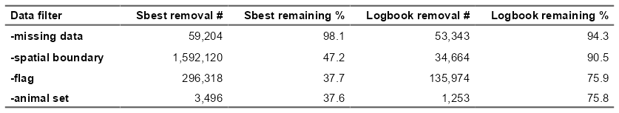

What country a vessel originates from can be an important variable in determining fishing strategy. Flag is a routinely recorded field that is used to determine this. However, it is imperfect as vessels can change their flag for various reasons and have done so through time such as countries chartering vessels to fish their domestic waters. Given the inability to reliably disentangle this issue, flag is used herein as a proxy for this as a catchability variable. Due to poor temporal coverage of many flags, only 10 flags were included in the model: Federated States of Micronesia (FM), Japan (JP), Kiribati (KI), Korea (KR), Papua New Guinea (PG), Philippines distant water fleet (PH), Solomon Islands (SI), Taiwan (TW), United States of America (US), and Vanuatu (VU) (Figure 6). Due to a lack of data, Philippines (PH) was also removed from the logbook data.

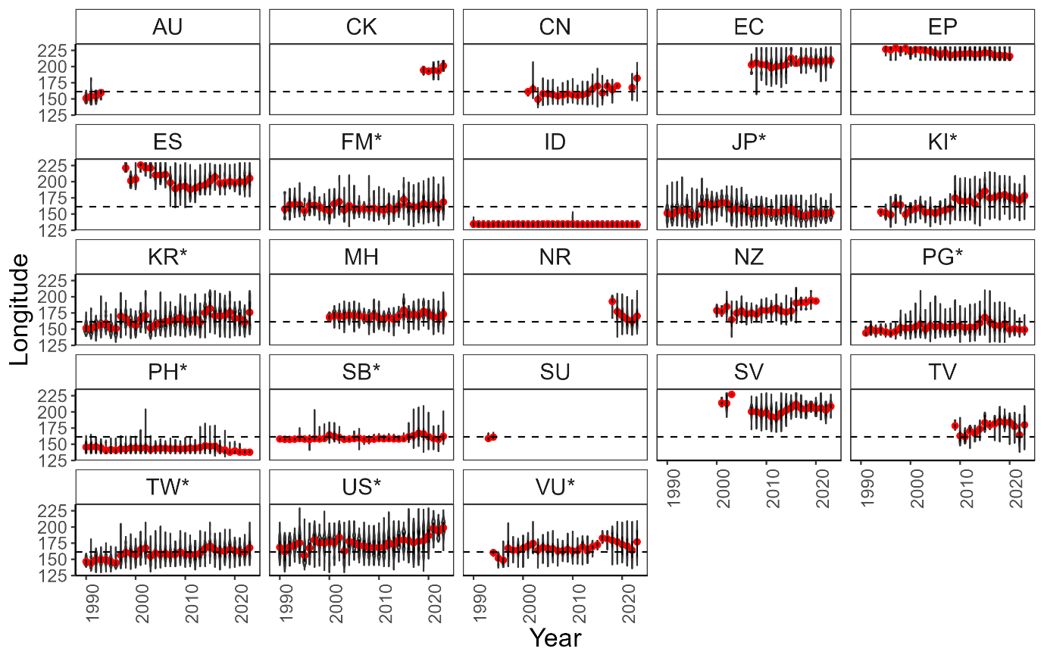

Figure 6: Longitudinal distribution of purse seine sets by flag and year using violin plots showing the lack of temporal spread of some flags to inform the model. * Flags are those kept in the model data. Dashed line represents the mean longitude of all purse seine sets. Red dots represent the annual mean longitude of purse seine sets for each year and flag combination.

Set type is another important variable in determining fishing strategy. The most important distinguishing feature is whether the set was unassociated (i.e. a free school set), or associated with some object (i.e. log, whale, man-made FAD). In previous analyses, set type is either filtered to unassociated sets only (Teears et al., 2022), or set type is included as a variable with data grouped into associated or unassociated sets (Vidal et al., 2020). Given that the objective of this analysis was to model longitudinal shifts in effort distribution over time, three groups were assigned including unassociated sets, drifting-FAD associated sets, and anchored FAD associated sets. This allowed the distribution of drifting-FAD associated sets to differ from anchored-FAD sets which behave differently in terms of longitude. Given low sample sizes across time, sets made on animals (e.g. whale sharks) were omitted from the data.

ENSO is a large recurring climate pattern that drives changes in the distribution of warm waters in the WCPO. ENSO driven shifts in the warm pool drive concomitant changes in the distribution of purse seine effort and catch. Most notably, an eastward shift in purse seine catch and effort with the eastward expansion of the western pacific warm pool (Lehodey et al., 2003). Monthly oceanic nino index (ONI) data were downloaded and categorised into el nino, la nina, or neutral events to be used as a variable in the model (<https://psl.noaa.gov/data/timeseries/month/>).

For the final filtered datasets, SBEST had 37% of the raw data remaining (n = 1,173,475), and 75% for the logbook data (n = 704,740) (Table 1).

### Model

Generalised additive models (GAMs) were applied in the R environment using the ‘*mgcv’* package with both logbook and SBEST aggregated purse seine data (R Core Team, 2024; Wood, 2011). Use of GAMs allows the model to flexibly fit non-linear relationships to the data which were to be expected. Models were fit with longitude as the response variable, and a range of variables known to influence catch and effort (Table 2). Variables explored included set type, flag, ENSO phase, year, month, and latitude. A gamma distribution with log link was assigned for all models.

Several different ways of treating both year and flag were explored to see their effect on model performance. This included year as a linear variable and flag as a random factor, year and flag as factors, year and flag as an independent interaction term, and year and flag as a common interaction term. Modelling year and flag with an independent interaction term was fit using thin plate regression splines and allowed the model to assume that each smooth term across years for each flag were independent with no information shared between them. In contrast, fitting year and flag with a common interaction term fits a smooth across years for each flag, but there is shared information with a factor-smooth interaction.

Once a preferred model was identified, this model was run with several variations including: with logbook data instead of SBEST, with log catch per set as a weighting variable, and with unassociated sets only which more closely aligns with models undertaken for the skipjack tuna stock assessment (Teears et al., 2022). This was done to explore the robustness of the model results and how different data inputs influence them.

Table 2: Description of generalised additive models applied to determine shifts in the longitudinal position of WCPFC tuna purse seine fishery over time. Longitude was the response variable for all models, and all models had family = Gamma(link = ‘log”).

|  |  |  |  |
| --- | --- | --- | --- |
| **Model** | **Name** | **Data** | **Formula** |
| **modA** | Linear | SBEST 1x1 | *lond ~ yy + s(mm, k = 6, bs ="cc") +* *s(flag, bs = "re", k = 10) + set_type + oniF + s(latd, k=5)* |
| **modB** | Factor | SBEST 1x1 | *lond ~ yyF + s(mm, k = 6, bs ="cc") + flag + set_type + oniF + s(latd, k=5)* |
| **modC** | Year:flag independent smooth | SBEST 1x1 | *lond ~ s(yy, by = flag) + s(mm, k = 6, bs ="cc") + set_type + oniF + s(latd, k=5)* |
| **modD** | Year:flag common smooth | SBEST 1x1 | *lond ~ s(yy, flag, bs = ‘fs’) + s(mm, k = 6, bs ="cc") + set_type + oniF + s(latd, k=5)* |
| **modE** | modD logcpue wts | SBEST 1x1 | *lond ~ s(yy, flag, bs = ‘fs’) + s(mm, k = 6, bs ="cc") + set_type + oniF + s(latd, k=5), weights = log(cpue)* |
| **modF** | modD unassoc. sets only | SBEST 1x1 (unassoc. sets) | *lond ~ s(yy, flag, bs = ‘fs’) + s(mm, k = 6, bs ="cc") + set_type + oniF + s(latd, k=5)* |
| **modG** | modD logbook data | Logbook | *lond ~ s(yy, flag, bs = ‘fs’) + s(mm, k = 6, bs ="cc") + set_type + oniF + s(latd, k=5)* |

## Results

Model performances are summarised in Table 3. Overall, all models provided relatively stable and consistent trends across the year effect and variable responses. model D using a year:flag common interaction term performed best with the lowest AIC overall across the four models that used the same input dataset, and the most deviance explained with 52.8%. Similar model results were achieved using log CPUE weights (modE), when running the model with unassociated sets only (modF), and with logbook data (modG) (Table 3).

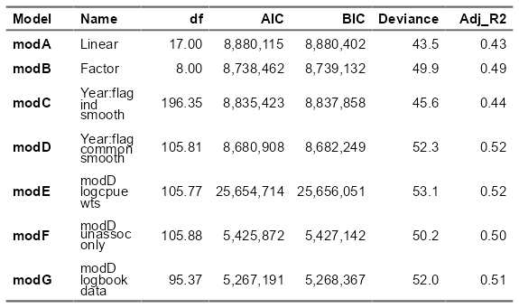

Table 3: Evaluation statistics of generalised additive models applied to determine shifts in the longitudinal position of WCPFC tuna purse seine fishery over time.

Modelling outputs provide an improved, standardised index of predicted longitude over time in comparison to unstandardised outputs from the data (Figure 7). This shows an index fluctuating over time, with evidence of a shift eastwards from approximately 2005 onwards. Compared to the mean annual longitude from the data as the unstandardised index, it is apparent that the effects of other variables such as ENSO events and set type have been reduced, providing an improved index.

Model D used a common interaction term between year and flag (Figure 8). This interaction term allowed the model to flexibly fit to flags which can have different operating behaviours within and across years, but assumes a common underlying trend across years between the flags. There were two prominent ‘modes’ identified across year and flag, with one group of flags (Kiribati, Korea, Taiwan, United State of America, Vanuatu) showing a trend eastwards which largely consisted of distant water fleets that are wide ranging and can flexibly move throughout the convention area. A second group of flags (Federated States of Micronesia, Japan, Papua New Guinea, Philippines, Solomon Islands) did not show this same trend eastwards and consisted of PICT flags, Japan which generally fishes a similar area each year, and the Philippines which focuses on the high seas pockets. Greater uncertainty in the smooths were apparent in early and late years of the timeseries where less data were present for certain flags including Vanuatu and Kiribati in early years, and Philippines in recent years.

Figure 7: Predicted longitude from model D from 1990:2023 for the WCPFC purse seine fishery compared to the unstandardised mean annual longitude of the data.

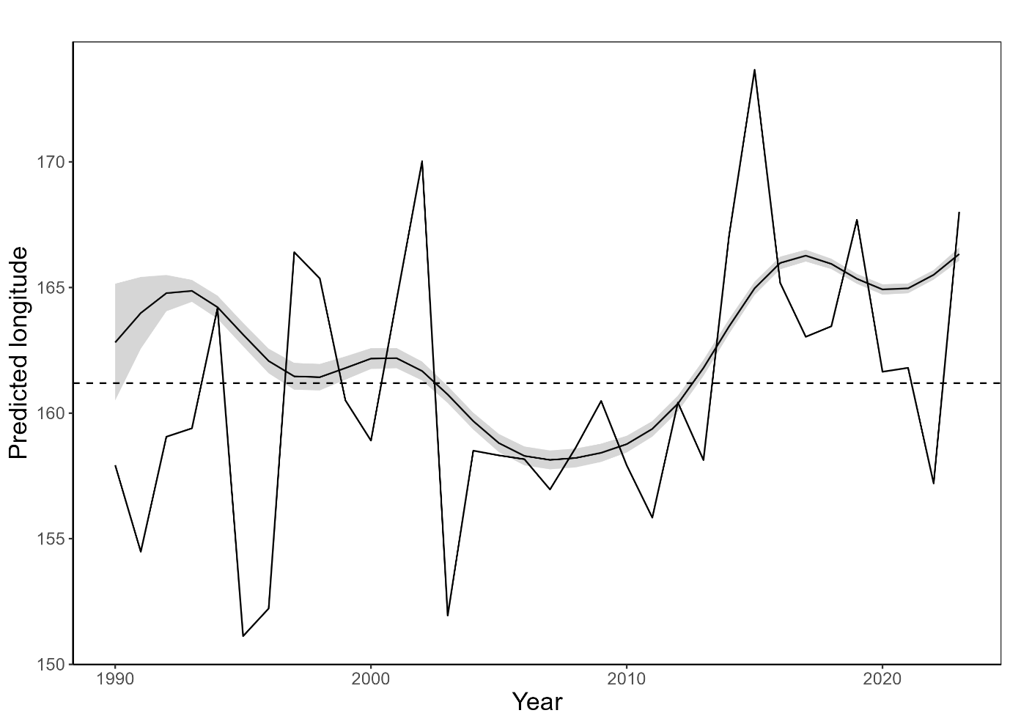

Figure 8: Year:flag common interaction smooths from model D split into flags that seem to show an eastward trend over time, and those where longitude has remained steady over time.

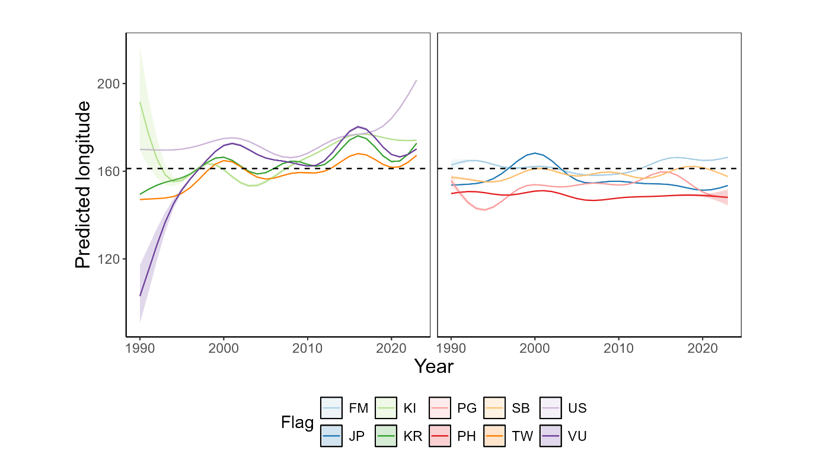

Across the variables, several trends that were apparent in the raw data were effectively captured by the model (Figure 9). For example, the model successfully captured that effort shifts longitudinally during ENSO events, namely eastwards during el nino events. The model also showed that drifting-FAD associated sets occur further east than anchored-FAD and unassociated sets. Lastly, it captured a minor seasonal trend with an eastward shift in effort during the second half of the year.

Figure 9: Variable response plots for model D including set type, month, and ENSO.

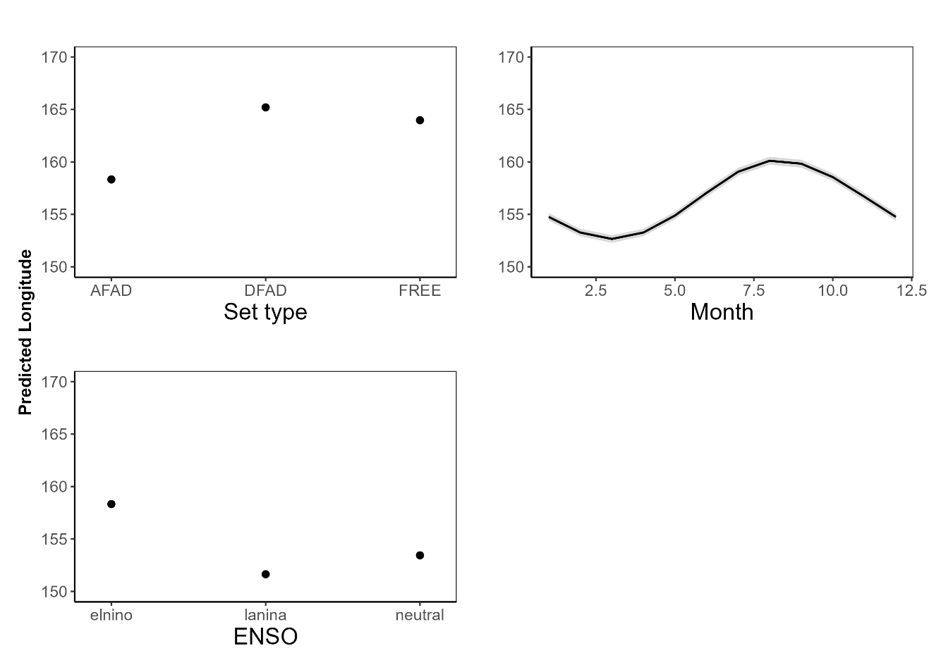

## Discussion

This analysis represents one of the first attempts to model long-term distribution shifts in effort of the WCPFC purse seine fishery to explore evidence of the impacts of climate change. Although preliminary, these results present a substantial step forward in understanding the underlying drivers of change in the spatial distribution of purse seine effort and will help inform ecosystem and climate indicator design. Results show disparate trends between two different ‘modes’ of vessel flag, with some flags showing an eastward shift which are generally distant water flags that can flexibly move throughout the convention area. The second mode showed no longitudinal trend over time and are generally static in their spatial distribution of effort. It remains somewhat unclear whether a climate-driven shift in purse seine effort is occurring and aligns with predictions (Bell et al., 2021), but results do suggest that if such a shift is occurring, that the ability of different fleets to adapt will vary.

What drives fishing effort location in the WCPFC purse seine fishery is dynamic. This analysis identified that several of the major distant water flags have shifted eastwards in their effort distribution over time while accounting for several variables known to influence effort (text about VDS, country agreements etc here maybe?). For another mode of flags, the longitudinal distribution of effort was largely static over time. These flags were either PICT nations that largely fish within their own EEZs and regularly fish anchored FADs (e.g. PG, SB), or flags that are restricted in their spatial distribution for some other reason like the Philippines which largely fishes in the high seas pockets, and Japan whose fleet generally fishes a similar area most years.

As the WCPO continues to be impacted by climate change, the adaptability of the purse seine fishery and different flags will be variable. Those distant water fleets that flexibly move throughout the convention area will be able to follow favourable conditions for fishing, while the second mode of flags may be less able to do so. This may result in a ‘winners’ and ‘losers’ scenario where some vessels or flags are able to adapt to the impacts of climate change, while others are more susceptible to its impacts and see declines in catches or catch rates. To adapt to climate change, the WCPFC and member countries for example could consider updated arrangements that determine where and when vessels can fish to counteract shifts in tuna distribution (Bell et al., 2021).

Care needs to be taken when interpreting trends from simple, empirical climate and ecosystem indicators. Several variables known to influence purse seine fishing also influence the longitudinal distribution of purse seine effort. By modelling longitude while accounting for several of these variables, a more reliable index was developed. Outputs showed a smoother trend in longitude over time relative to catch and effort COG indicators, reducing the influence of variables such as ENSO and flag. However, the overall trend between the modelled index and COG of catch and effort are relatively similar, showing a variable trend with slight evidence for an eastwards shift over time. This shows that these climate and ecosystem indicators do have merit in being monitored, but that they can be improved. By exploring these indicators across various pertinent variable levels (e.g. set type), or by explicitly accounting for them in a model such as has been done herein, an improved understanding of both the fishery and how the climate and environment are impacting it can be achieved.

Another option could be to explore the use of ‘indicator’ flags or fleets that can act as proxies to track changes in the fishery. Depending on the objective of the indicator, several flags identified in this analysis could be monitored in more detail to represent indicators of change in the purse seine fishery. If tracking longitudinal shifts, Korea (KR) and Taiwan (TW) may represent suitable indicator flags. These two flags fish throughout the convention area and have shown a consistent shift eastwards in their longitudinal distribution with Korea predominately setting on unassociated schools, and Taiwan drifting FADs. In contrast, one could monitor flags that are static over time to see if their catches or CPUE changes over time. In this case, the Philippines (PH), Japan (JP), or Solomon Islands (SB) could be more appropriate flags. These flags generally fish in the same areas each year and could represent a fishery dependent sampling program of sorts for these areas.

This analysis has several limitations. Firstly, is the overall difficulty associated with analysing purse seine data. It has proven difficult to determine a robust measure of effort and consequently CPUE for the purse seine fishery given continuous technological (e.g. drifting FADs) and management changes. This analysis relied on sets as the measure of effort which does not incorporate pertinent factors like search time (Teears et al., 2022). Secondly, is the quality and resolution of the aggregated and logbook input data. The aggregated data does not report information at the operational level which is important for identifying trends at an appropriate resolution while a lack of reporting means that the logbook data is incomplete. Other studies that have attempted to analyse the WCPFC purse seine fishery have generally relied on the more robust observer program data, but this information is only complete from 2010 onwards making it difficult to discern long term trends (Teears et al., 2022; Vidal et al., 2020). Given that this analysis only extends back to 1990, it will be important to continue monitoring these indicators so that a better understanding can be gained on how this index is influenced by other sources of variability, such as Interdecadal Pacific Oscillation which operates on longer timescales.

Another limitation is the use of the flag column as a variable to group fishing behaviour. Vessels can interchange their designated flag for various reasons depending on where they’re fishing, charter arrangements and so on. To overcome this, the analysis could use vessel ID as an alternative, but this would result in the fitting of hundreds of smoothers. Lastly, is that many variables influence where purse seine fishing occurs. Although this analysis represents a step forward in considering some of these variables, there are various others (e.g. VDS, management changes, environmental, vessel size) that have not been considered here that may also be influencing the longitudinal distribution of effort over time.

Recently, CPUE standardisation approaches have increasingly shifted towards spatiotemporal approaches (Anderson et al., 2022; Teears et al., 2022; Thorson, 2019). Application of a spatiotemporal model could be explored which explicitly considers spatial and temporal autocorrelation, and where centre of gravity metrics can be extracted directly using packages such as *sdmTMB (Anderson et al., 2022)*. As the timeseries of the observer program increases, this data could also be incorporated into model exploration to see how outputs from it compare to the SBEST and logbook data. Lastly, environmental variables like sea surface temperature and thermocline depth could be incorporated into the model to see if it helps model performance and explanatory power.

This analysis presents a first attempt to explicitly model long-term changes in the longitudinal distribution of the WCPFC purse seine fishery. It identified two modes of vessel flag, showing two different trends in longitude over time with one mode shifting eastwards, and one remaining static. It also showed that despite empirical COG indicators being influenced by several other variables, they still captured broadly correct trends in longitude over time. These outcomes will not only help to inform the design of ecosystem and climate indicators going forward, it has shown that responses to climate change by the WCPFC purse seine fishery are likely to be variable, and that some fleets will be more susceptible than others which has important management implications.

# References

Allain, V., Hare, S., Macdonald, J., Machful, P., Nicol, S., Phillips, J.S., Portal, A., Vidal, T., Williams, P., 2021. WCPO Ecosystem and Climate Indicators from 2000 to 2020. Online.

Allain, V., Macdonald, J., Nicol, S., Phillips, J.S., Vourey, E., 2020. Ecosystem and climate indicators for consideration within the WCPO. Online.

Anderson, S.C., Ward, E.J., English, P.A., Barnett, L.A.K., Thorson, J.T., 2022. sdmTMB: An R Package for fast, flexible, and user-friendly generalized linear mixed ffects models with spatial and spatiotemporal random fields. bioRxiv. https://doi.org/10.1101/2022.03.24.485545

Anon, 2015. Summary Report: Commission for the Conservation and Management of Highly Migratory Fish Stocks in the Western and Central Pacific Ocean. Pohnpei.

Antão, L.H., Bates, A.E., Blowes, S.A., Waldock, C., Supp, S.R., Magurran, A.E., Dornelas, M., Schipper, A.M., 2020. Temperature-related biodiversity change across temperate marine and terrestrial systems. Nat Ecol Evol. https://doi.org/10.1101/841833

Ashida, H., 2020. Spatial and temporal differences in the reproductive traits of skipjack tuna Katsuwonus pelamis between the subtropical and temperate western Pacific Ocean. Fish Res 221, 105352. https://doi.org/10.1016/j.fishres.2019.105352

Bell, J.D., Allain, V., Allison, E.H., Andréfouët, S., Andrew, N.L., Batty, M.J., Blanc, M., Dambacher, J.M., Hampton, J., Hanich, Q., Harley, S., Lorrain, A., McCoy, M., McTurk, N., Nicol, S., Pilling, G., Point, D., Sharp, M.K., Vivili, P., Williams, P., 2015. Diversifying the use of tuna to improve food security and public health in Pacific Island countries and territories. Mar Policy 51, 584–591. https://doi.org/10.1016/j.marpol.2014.10.005

Bell, J.D., Senina, I., Adams, T., Aumont, O., Calmettes, B., Clark, S., Dessert, M., Gehlen, M., Gorgues, T., Hampton, J., Hanich, Q., Harden-Davies, H., Hare, S.R., Holmes, G., Lehodey, P., Lengaigne, M., Mansfield, W., Menkes, C., Nicol, S., Ota, Y., Pasisi, C., Pilling, G., Reid, C., Ronneberg, E., Gupta, A. Sen, Seto, K.L., Smith, N., Taei, S., Tsamenyi, M., Williams, P., 2021. Pathways to sustaining tuna-dependent Pacific Island economies during climate change. Nat Sustain 4, 900–910. https://doi.org/10.1038/s41893-021-00745-z

CSIRO, BOM, 2025. State of The Climate 2024.

FAO, 2024. The State of World Fisheries and Aquaculture 2024 - Blue Transformation in action, The State of World Fisheries and Aquaculture 2024. FAO, Rome. https://doi.org/10.4060/cd0683en

Farley, J., Eveson, P., Krusic-Golub, K., Sanchez, C., Roupsard, F., Mckechnie, S., Nicol, S., Leroy, B., Smith, N., Chang, S.-K., 2017. Project 35: Age, growth and maturity of bigeye tuna in the western and central Pacific Ocean. Rarotonga.

Fujioka, K., Aoki, Y., Tsuda, Y., Okamoto, K., Tsuchida, H., Sasaki, A., Kiyofuji, H., 2024. Influence of temperature on hatching success of skipjack tuna (Katsuwonus pelamis): Implications for spawning availability of warm habitats. J Fish Biol 105, 372–377. https://doi.org/10.1111/jfb.15767

Garciá Molinos, J., Burrows, M.T., Poloczanska, E.S., 2017. Ocean currents modify the coupling between climate change and biogeographical shifts. Sci Rep 7. https://doi.org/10.1038/s41598-017-01309-y

Gillett, R., Fong, M., 2023. Fisheries in the Economies of Pacific Island Countries and Territories (Benefish Study 4). Noumea.

Griffiths, S., Fuller, L., 2019. Ecosystem Considerations. San Diego.

Hoegh-Guldberg, O., Bruno, J.F., 2010. The impact of climate change on the world’s marine ecosystems. Science (1979). https://doi.org/10.1126/science.1189930

Hoyle, S.D., Campbell, R.A., Ducharme-Barth, N.D., Grüss, A., Moore, B.R., Thorson, J.T., Tremblay-Boyer, L., Winker, H., Zhou, S., Maunder, M.N., 2024. Catch per unit effort modelling for stock assessment: A summary of good practices. Fish Res 269, 106860. https://doi.org/10.1016/j.fishres.2023.106860

Johnson, C.R., Banks, S.C., Barrett, N.S., Cazassus, F., Dunstan, P.K., Edgar, G.J., Frusher, S.D., Gardner, C., Haddon, M., Helidoniotis, F., Hill, K.L., Holbrook, N.J., Hosie, G.W., Last, P.R., Ling, S.D., Melbourne-Thomas, J., Miller, K., Pecl, G.T., Richardson, A.J., Ridgway, K.R., Rintoul, S.R., Ritz, D.A., Ross, D.J., Sanderson, J.C., Shepherd, S.A., Slotwinski, A., Swadling, K.M., Taw, N., 2011. Climate change cascades: Shifts in oceanography, species’ ranges and subtidal marine community dynamics in eastern Tasmania. J Exp Mar Biol Ecol. https://doi.org/10.1016/j.jembe.2011.02.032

Juan-Jordá, M., Murua, H., Apostolaki, P., Lynam, C., Rodriguez, A., Barrionuevo, J., Abascal, F., Coelho, R., Todorovic, S., Billet, N., Uyarra, M., Andonegi, E., Lopez, J., 2019. Selecting ecosystem indicators for fisheries targeting highly migratory species: An EU project to advance the operationalization of the EAFM in ICCAT and IOTC. Pohnpei.

Juan-Jordá, M.J., Murua, H., Arrizabalaga, H., Hanke, A., 2018. A template for an indicator-based ecosystem report card for ICCAT, Sci. Pap. ICCAT.

Lehodey, P., Bertrand, A., Hobday, A.J., Kiyofuji, H., McClatchie, S., Menkès, C.E., Pilling, G., Polovina, J., Tommasi, D., 2020. ENSO Impact on Marine Fisheries and Ecosystems, in: Geophysical Monograph Series. John Wiley and Sons Inc, pp. 429–451. https://doi.org/10.1002/9781119548164.ch19

Lehodey, P., Chai, F., Hampton, J., 2003. Modelling climate-related variability of tuna populations from a coupled ocean-biogeochemical-populations dynamics model. Fish Oceanogr 12, 483–494.

Lehodey, P., Senina, I., Calmettes, B., Hampton, J., Nicol, S., 2013. Modelling the impact of climate change on Pacific skipjack tuna population and fisheries. Clim Change 119, 95–109. https://doi.org/10.1007/s10584-012-0595-1

Leung, J.C.H., Zhang, B., Gan, Q., Wang, L., Qian, W., Hu, Z.Z., 2022. Differential expansion speeds of Indo-Pacific warm pool and deep convection favoring pool under greenhouse warming. NPJ Clim Atmos Sci 5. https://doi.org/10.1038/s41612-022-00315-w

Macdonald, J., Williams, P., Roupsard, F., Sanchez, C., Bell, L., Chang, S.-K., Contreras, R., Ghergariu, M., Hosken, M., Hoyle, S., Cuu, S.N., Park, T., Potts, J., Schneiter, E., Nicol, S., 2023. Project 90 update: Better data on fish weights and lengths for scientific analyses. Koror.

Macdonald, J., Williams, P., Sanchez, C., Schneiter, E., Prasad, S., Ghergariu, M., Hosken, M., Panizza, A., Park, T., Guillou, A., Nicol, S., 2022. Project 90 update: Better data on fish weights and lengths for scientific analyses. Online.

Magnusson, A., Day, J., Teears, T., Hampton, J., Davies, N., Castillo Jordán, C., Peatman, T., Scott, R., Scutt Phillips, J., Mckechnie, S., Scott, F., Yao, N., Natadra, R., Pilling, G., Williams, P., Hamer, P., 2023. Stock assessment of yellowfin tuna in the western and central Pacific Ocean: 2023. Koror.

McGree, Simon., Smith, Grant., Chandler, Elise., Harold, Nicholas., Begg, Zulfikar., Kuleshov, Yuriy., Malsale, Philip., Ritman, Mathilde., 2022. Climate Change in the Pacific 2022: historical and recent variability, extremes and change. Pacific Community (SPC), Suva.

Ohashi, S., Aoki, Y., Tanaka, F., Fujioka, K., Aoki, A., Kiyofuji, H., 2019. Reproductive traits of female skipjack tuna Katsuwonus pelamis in the western and central Pacific Ocean (WCPO). Pohnpei.

Pecl, G.T., Araújo, M.B., Bell, J.D., Blanchard, J., Bonebrake, T.C., Chen, I.-C., Clark, T.D., Colwell, R.K., Danielsen, F., Evengård, B., Falconi, L., Ferrier, S., Frusher, S., Garcia, R.A., Griffis, R.B., Hobday, A.J., Janion-Scheepers, C., Jarzyna, M.A., Jennings, S., Lenoir, J., Linnetved, H.I., Martin, V.Y., McCormack, P.C., McDonald, J., Mitchell, N.J., Mustonen, T., Pandolfi, J.M., Pettorelli, N., Popova, E., Robinson, S.A., Scheffers, B.R., Shaw, J.D., Sorte, C.J.B., Strugnell, J.M., Sunday, J.M., Tuanmu, M.N., Vergés, A., Villanueva, C., Wernberg, T., Wapstra, E., Williams, S.E., 2017. Biodiversity redistribution under climate change: Impacts on ecosystems and human well-being. Science (1979). https://doi.org/10.1126/science.aai9214

Pinsky, M.L., Selden, R.L., Kitchel, Z.J., 2020. Climate-Driven Shifts in Marine Species Ranges: Scaling from Organisms to Communities. Ann Rev Mar Sci 12, 153–179. https://doi.org/10.1146/annurev-marine-010419

Poloczanska, E.S., Brown, C.J., Sydeman, W.J., Kiessling, W., Schoeman, D.S., Moore, P.J., Brander, K., Bruno, J.F., Buckley, L.B., Burrows, M.T., Duarte, C.M., Halpern, B.S., Holding, J., Kappel, C. V., O’Connor, M.I., Pandolfi, J.M., Parmesan, C., Schwing, F., Thompson, S.A., Richardson, A.J., 2013. Global imprint of climate change on marine life. Nat Clim Chang 3, 919–925. https://doi.org/10.1038/nclimate1958

Poloczanska, E.S., Burrows, M.T., Brown, C.J., Molinos, J.G., Halpern, B.S., Hoegh-Guldberg, O., Kappel, C. V., Moore, P.J., Richardson, A.J., Schoeman, D.S., Sydeman, W.J., 2016. Responses of marine organisms to climate change across oceans. Front Mar Sci. https://doi.org/10.3389/fmars.2016.00062

R Core Team, 2024. R: A language and environment for statistical computing.

Rufino, M.M., Bez, N., Brind’Amour, A., 2018. Integrating spatial indicators in the surveillance of exploited marine ecosystems. PLoS One 13. https://doi.org/10.1371/journal.pone.0207538

Senina, I., Sibert, J., Lehodey, P., 2008. Parameter estimation for basin-scale ecosystem-linked population models of large pelagic predators: Application to skipjack tuna. Prog Oceanogr 78, 319–335. https://doi.org/10.1016/j.pocean.2008.06.003

Smith, N., Allain, V., Pilling, G., 2016. Ecosystem indicators: moving forward to design and testing. Bali.

SPC, 2024. Ecosystem and climate indicators. Manila.

SPC, 2023. Ecosystem and Climate Indicators. Koror.

SPC, 2022. Ecosystem and climate indicators. Online.

Taylor, N.G., Walter, J.F., 2024. Incorporating climate considerations into fisheries assessments and management advice at ICCAT, Collect. Vol. Sci. Pap. ICCAT.

Teears, T., Aoki, Y., Matsubura, N., Tsuda, Y., Castillo Jordan, C., Hampton, J., Schneiter, E., Scutt Phillips, J., Peatman, T., Bigelow, K., Hamer, P., 2022. Background analyses and data inputs for the 2022 skipjack tuna stock assessment in the Western and Central Pacific Ocean.

Thorson, J.T., 2019. Guidance for decisions using the Vector Autoregressive Spatio-Temporal (VAST) package in stock, ecosystem, habitat and climate assessments. Fish Res 210, 143–161. https://doi.org/10.1016/j.fishres.2018.10.013

Vidal, T., Hamer, P., Escalle, L., Pilling, G., 2020. Assessing trends in skipjack tuna abundance from purse seine catch and effort data in the WCPO.

Weller, E., Min, S.K., Cai, W., Zwiers, F.W., Kim, Y.H., Lee, D., 2016. Human-caused Indo-Pacific warm pool expansion. Sci Adv 2, e1501719. https://doi.org/10.1126/sciadv.1501719

WMO, 2025. State of the Climate in the South-West Pacific 2024. Geneva.

Wood, S.N., 2011. Fast stable restricted maximum likelihood and marginal likelihood estimation of semiparametric generalized linear models. J R Stat Soc Series B Stat Methodol 73, 3–36. https://doi.org/10.1111/j.1467-9868.2010.00749.x